Aim:

To create a SQL database in a public cloud and perform basic queries, demonstrating Database as a Service (DaaS) functionality.

Procedure:

1. Login to Azure Portal and create a Resource Group (db-demo-rg).
2. Create SQL Database:
   * Database name: studentdb
   * Create new server: sqldemolab123
   * Admin login: dbadmin, Password: YourPassword123
   * Compute tier: Basic
   * Networking: Public endpoint, allow your IP.
3. Deploy the database.
4. Connect via Query Editor using dbadmin and password.
5. Run queriesresul

SQL Database overview :

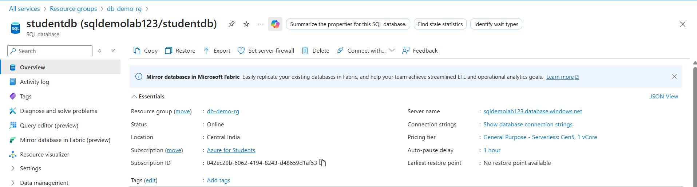

Query Editor:

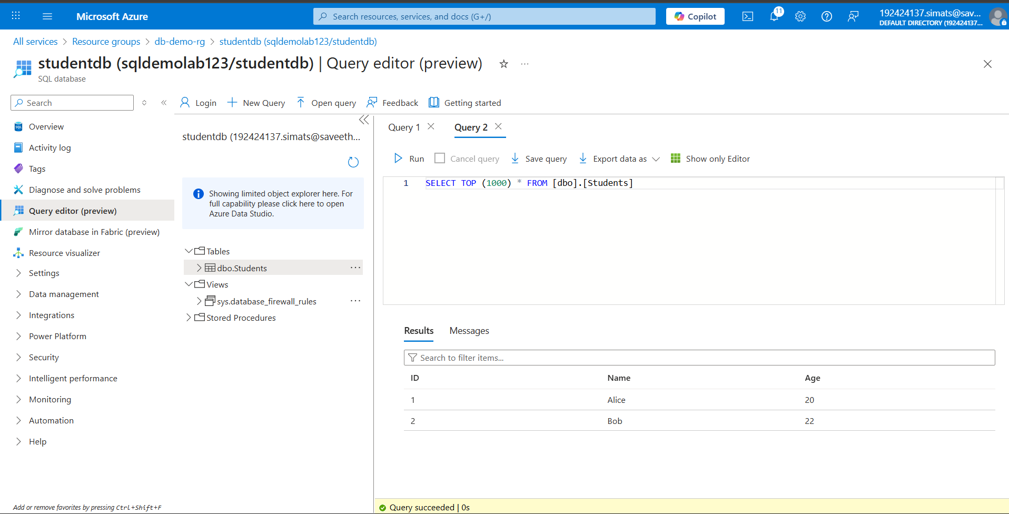

Result:

A SQL database was successfully created in Azure. Basic SQL operations were performed, demonstrating connectivity, table creation, record insertion, and data retrieval — confirming Database as a Service (DaaS) functionality.